Write a short scenario for online paid table booking system in chain restaurants with designing the use case diagram and use case description.

**Scenario**

A customer named Saurav decides to plan a dinner with his wife at one of his favorite chain restaurant. He logs into the restaurant’s booking platform, browses for location and checks for table availability on his desired date and time. He then reserves a table, confirms his details, and securely pays a booking deposit through an integrated payment gateway. Once his payment is processed, Saurav immediately receives a confirmation notification via email and SMS, and the restaurant manager is alerted to update the seating plan accordingly.

**Use case Diagram**

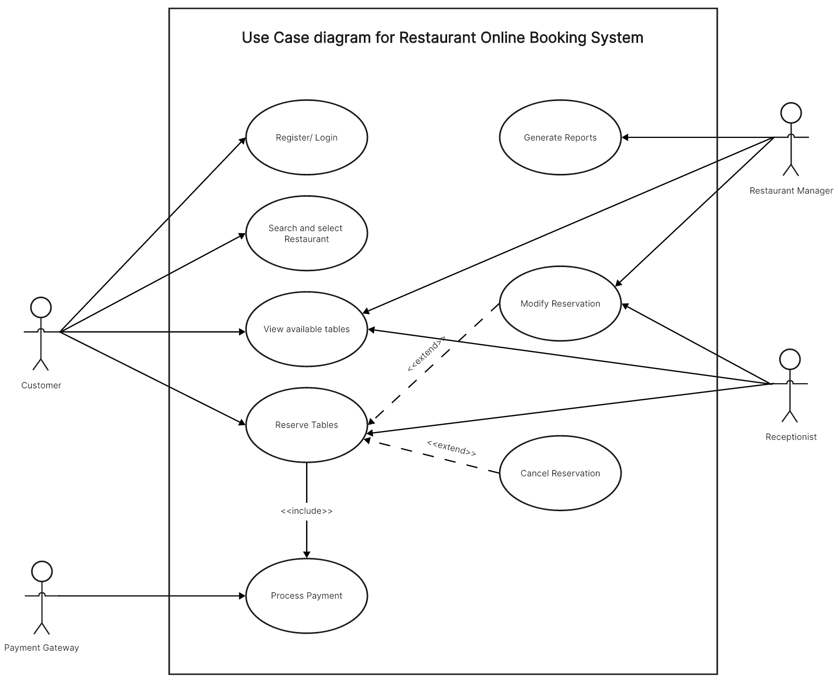

**Actors:**

**Customer**: Interacts with the system by logging in, searching for restaurants, view table availability, reserve a table and cancel or modify reservations if necessary.

**Restaurant Manager**: Oversees the reservations like modifying, confirming or cancelling and generates reports for occupancy and revenue management.

**Receptionist**: Ensures that bookings are accurately managed and that customer requests for changes or cancellations are handled efficiently.

**Payment Gateway**: Process the payment as part of the booking flow.

**User Case Description:**

1. **Login/Register:** The customer authenticates into the system.
2. **Search and Select Restaurant:** The customer searches for the desired restaurant branch using location filters.
3. **View Availability:** The system displays available tables for the chosen date and time.
4. **Reserve Tables:** The customer selects a preferred table along with a booking time.
5. **Confirm Reservation:** The customer reviews the booking details and confirms by proceeding to payment.
6. **Process Payment:**
   * The system routes the payment details to the Payment Gateway.
   * The payment gateway verifies and processes the payment.
7. **Booking Confirmation:** Upon successful payment, the system updates the booking status, sends a confirmation notification (via email/SMS), and alerts the restaurant manager to prepare accordingly.